WriterDuet Digital Literacy Assessment

Project Description
WriterDuet is an online screenwriting software that allows the user to work by themselves or collaboratively to plan, write, edit, and share screenplays. While there are several paid options for this program, the free version allows the possibility to work on up to 3 projects at once, free exporting, industry formatting, and more (more information on the free vs. paid programs here). While WriterDuet will give you several opportunities to buy a subscription, the free version has more than enough tools to allow amateur screenwriters to work on their screenplays. Programs like Microsoft Word or Google Docs allow similar capabilities, but WriterDuet is specficially set up for screenwriting and scriptwriting. WriterDuet is certainly a software for all to explore, but this rubric (and the program itself) is best suited for amateur screenwriters who are working on short or feature screenplays. Screenplays include a variety of different elements and line types including:

- Title Page: The first page of the screenplay with the title and author name.
- Scene Headings: One line description of the location and time of day (including interior [INT] or exterior [EXT]).
- Characters: Names or identifiers of the character who is speaking.
- Actions: Description of the action in a scene
- Dialogue: Lines of speech that a character says
- Scene Numbers: Numbers each scene heading
- Transitions: Transitional instructions for editing (such as CUT TO)
- Shots: indicates the camera angle or movement in a scene
- Parentheticals: Information on how a character should say a line (written in parentheticals)
- Extensions: Clarifies where a character is when they can’t be seen
- Subheaders: Used when there are minor changes in location (down the hall, location attached to scene setting)
- Intercuts: Instructions when cutting to multiple locations
- Fade In/Out: Marks the start and end of the screenplay
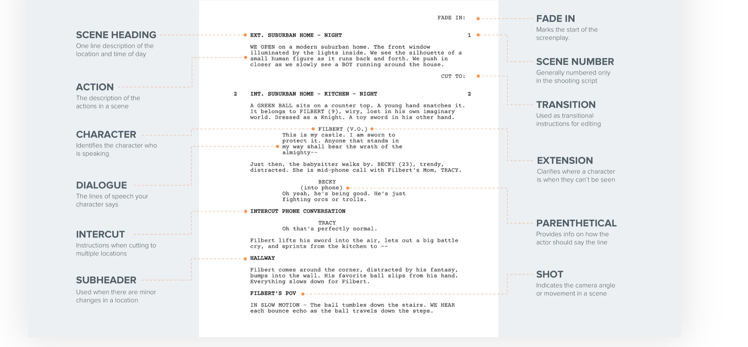

(To read more about each element of a screenplay, visit: https://www.studiobinder.com/blog/how-to-write-a-screenplay/)

On top of including the many elements and line types, a screenplay should also include visual cues that would allow it to be adapted by a camera. This includes visually descriptive language, notes about the setting (weather, time, etc.), character descriptions, and more. The best screenplays will have both a compelling narrative/story and also the right line types/visual cues for it to be adapted to the screen.

Examples of Screenplays
“The Premonition” by Nina Braddock
“The Washing Machine” by Lorena Padilla
“Running” by Divya Mangwani

These three screenplays are short excerpts that allow the reader to see the proper formatting of screenplays and how they are combined with the story itself.

Necessary Northstar Skills

Basic Computer Skills
- Demonstrate knowledge of keys on keyboard (Enter, Shift, Control, Backspace, Delete, Arrow Keys, Tab, Caps Lock, Number Lock).
- Demonstrate knowledge and appropriate use of mouse clicks (right-click, left-click, and double click).
- Utilize common controls for screen interaction (selecting check boxes, using drop-down menus, scrolling).
- Identify mechanisms for storing files (flash drives, hard drives, cloud-based storage).

Internet Basics*
- Demonstrate familiarity with website structure (e.g., landing pages, internal pages).
- Demonstrate understanding of how to use browser tools and settings to protect privacy (e.g., private browser windows, clearing search history, and declining to save passwords on shared computers).
- Demonstrate understanding of when it's safe and appropriate to share personal, private, or financial information (e.g., recognizing phishing attempts, identifying unsecured websites).
- Fill out an online form.
- Identify address bar and demonstrate understanding of its functionality
- Identify common browser tools and icons (e.g., favorites, downloads, refresh, and back)
- Demonstrate ability to scroll up and down a page and left and right on a page.
- Identify and make use of common website interactions (e.g., play buttons, hyperlinks).
- Identify and work with tabs and windows.

*Please note that passing the Internet Basics Northstar Assessment is necessary for passing the WriterDuet Assessment (See Rubric)

Using Email
- Define email and identify common email clients.

WriterDuet Skills
- Create a free Sign-In, including username and password.
- Title your first project
- Select the free version of WriterDuet.
- Switch between Line Types by using the Line Types Toolbox (located by clicking this side menu button ) and clicking between the various line type buttons.
- Use the Tab key on the keyboard to switch between main Line Types (Scene, Action, Character, Transition).
- Type the Appropriate Content into each Line Type.
- Edit the Title Page including the name of the screenplay, the author’s name, and the author’s contact information by going to the Menu () > File > Title Page.
- Leave comments on your screenplay
- Navigate Time Machine () and switch between different auto-saved versions of your script.
- Save your project manually within Time Machine.
- Export your screenplay to a PDF by going to the Menu () > File > Export PDF > Default (Visible) .

Evaluation Rubric Learner:
Category | Advanced – 5pts | Proficient – 4pts | Progressing - 3pts
Completeness | Student completes a screenplay that is at least 4 pages long with at least 1 character who has dialogue. | Student completes a screenplay that is 2-4 pages long with at least 1 character. | Student completes a screenplay that is less than 2 pages.
Screenplay Formatting | Student demonstrates excellent understanding of at least 7 line types (including the 4 main types identified above) and uses them properly according to their purpose. | Student demonstrates some understanding of at least 4 line types (including at least 2 of the main types identified above) and uses them properly according to their purpose | Student demonstrates some of understanding of at least 2 line types.
Story Content | -Provides clear message and theme  -Originality in composition and delivery  - Uses Visual Cues to allow easy adaptation from page to screen | -Message/theme could be further teased out  -Somewhat original story and composition, relies on work not made by student in terms of content and style  - Uses Visual Cues to allow adaptation from page to screen, but needs more detail | -Unclear message/theme  -Relies heavily on work not original to student and does not integrate them well  - Does not use visual cues and adapting to the screen would be difficult.
WriterDuet Skills | Student shows mastery of the vast majority of outlined WriterDuet skills (at least 8) | Student shows mastery of some of the outlined WriterDuet skills (at least 6) | Student shows mastery of a few of the WriterDuet skills (at least 2)
Northstar Skills | Student shows mastery of the vast majority of outlined Northstar skills and passes the Northstar Internet Basics Assessment. | Student shows understanding of many outlined Northstar skills and passes the Northstar Internet Basics Assessment. | Student shows little understanding of outlined Northstar skills, but does pass the Northstar Internet Basics Assessment.

Score out of 25 ________________ (A score of 20 is passing)

