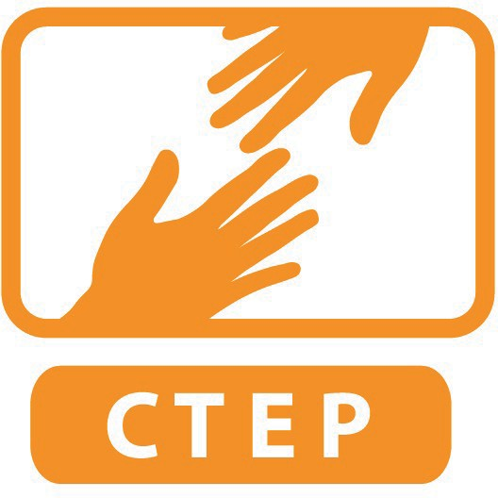
CTEP MEMBER SERVICE PLAN

Member Name:
Site Supervisor Name:
Service Site Name:
Member Signature: ___________________________________
Site Supervisor Signature: ______________________________
Date Reviewed and Approved by both Supervisor and Member: ___________

The purpose of the Service Plan is to solidify expectations of the member regarding direct service, capacity building, and volunteer management. These are the main tenets of their service as it correlates to the CTEP AmeriCorps grant’s program outcomes: employment and capacity building.

CTEP staff may ask site to revise the service plan periodically over the course of the year so that it remains current. Please ensure that both supervisor and member have a copy of this living document.

AGREED UPON SERVICE SCHEDULE:

Please set predictable start and end times for each day of the week at service site, averaging 7 hours a day, 5 days a week, or 35 hours/week total. This service schedule includes time for CTEP-related tasks (civic engagement, reporting, training, reflections, etc) which vary between 4 and 10 hours a week depending on whether there is a Corps day training that Friday, which leaves between 25 and 31 hours a week for site specific related activities. Please plan tasks in the service plan so that the member can balance site activities with CTEP responsibilities.

Monday:
Tuesday:
Wednesday:
Thursday:
Friday:
Saturday:
Sunday:

- DIRECT SERVICE ACTIVITIES

All direct service activities for the CTEP member must relate to teaching a technology skill in some way.

Narrative of all Direct Service Activities (include dates when helpful):

When will the CTEP member receive observation and constructive feedback from the site supervisor on direct service quality and effectiveness? How and how often will these observations occur?

1A) NORTHSTAR GOALS

One of CTEP’s program measures is for 2,450 individuals to receive education and job placement services. This translates to, per member, 50 community participants to become certified in a Northstar assessment over the course of the year. To meet this goal, in general, a site should plan for 100 community participants/learners/patrons to take a Northstar assessment over the course of the year. CTEP reports on how many unique community participants become certified. CTEP does not report on how many Northstar certifications a single community participant receives.

Which Northstar assessments will you concentrate on at your site? Circle or highlight all that apply:

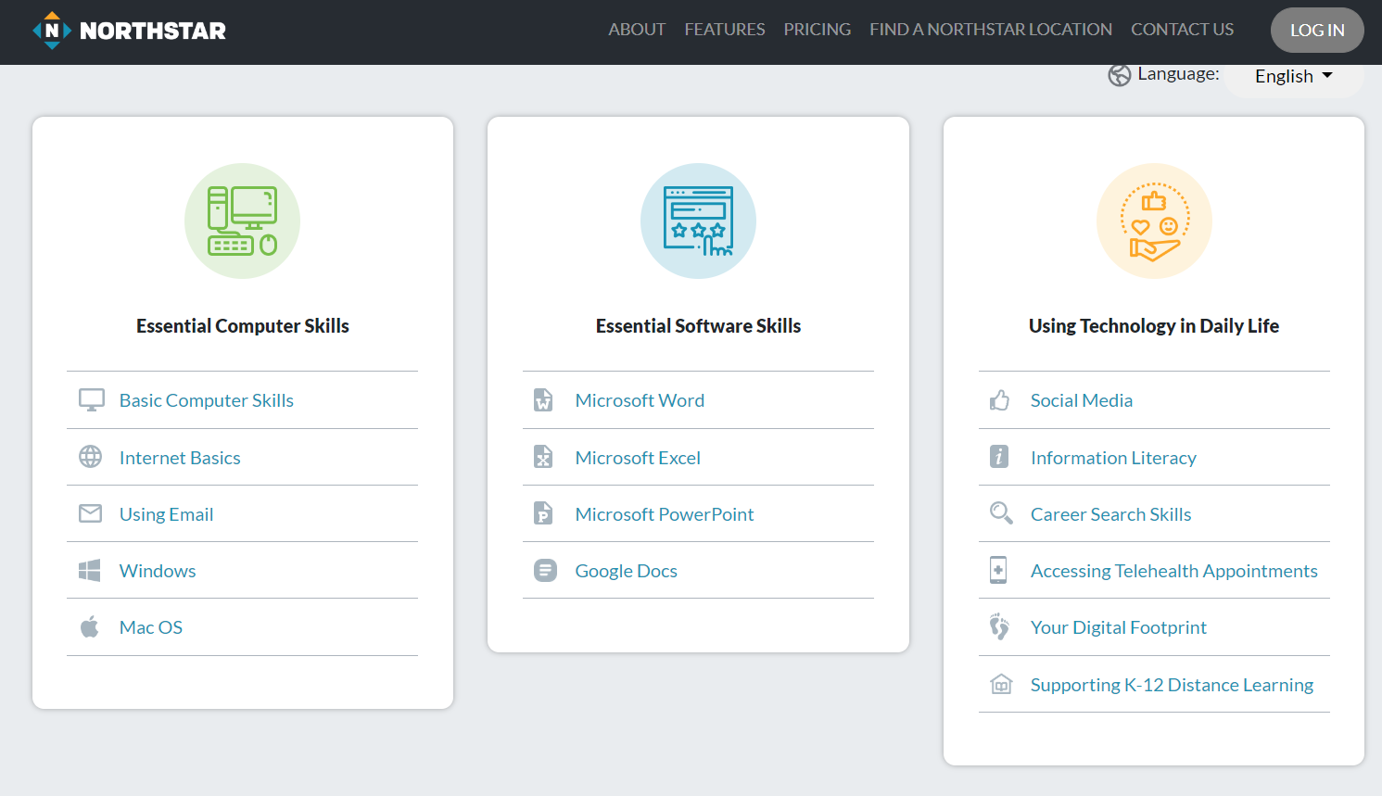

Other Assessments and Certifications:
- CTEP Customized Assessment (please specify):
- Typing (30 wpm, 85% accuracy)
- Microsoft Office Specialist (MOS) Certification
- Cisco / CompTIAA / Networking

Please estimate:
 | # Participants who will take a Northstar Digital Literacy post assessment this year
 | # Participants who become certified in Northstar this year
 | # Participants certified from this site last year (if applicable)
Estimate by reporting quarter: |  | Actual outcome:
 | # new people certified between Sept 8- Nov 15
 | # new people certified between Nov 16- Mar 20
 | # new people certified between Mar 21- Jun 19
 | # new people certified between Jun 20-Aug 31

1B) EMPLOYMENT GOALS

Our program goal is that 650 individuals will secure employment. This translates to 18 community participants per CTEP member will become employed through their instruction and assistance over the course of the year.

Please estimate:
# of participants you can verify become employed this year over the course of the year
# of participants the CTEP member verified became employed last year (if applicable)

Describe your site’s job placement skills training:

Describe your site’s system to find out if someone found a job:

2. CAPACITY BUILDING PROJECTS

CTEP asks all members to complete three capacity building projects over the course of the year. A capacity building project is a more substantial contribution to the programming by the member, typically requiring more than 10 hours to complete.

Project 1 Title:
Estimated Date to Complete:
Project Narrative:

Project 2 Title:
Estimated Date to Complete:
Project Narrative:

Project 3 Title:
Estimated Date to Complete:
Project Narrative:

3. PLAN TO RECRUIT AND/OR MANAGE VOLUNTEERS

CTEP defines a volunteer as: any unpaid community member who is contributing to the technology literacy programming at the site. A volunteer can also be a client as long as they are contributing to the organization even as they are receiving a service. Good examples of volunteers: Students performing unpaid service learning, unpaid internships, etc. Examples that would not count: paid interns, site staff, other AmeriCorps members from other programs.

You can’t count the same volunteer who you recruited as managed, but you have to choose one or the other. “Managing volunteers” is not necessarily the same thing as supervising them. It just means that the CTEP member enriched that volunteer’s experience in some way.

Our program goal is that each CTEP member will recruit an average of 5 volunteers serving 30 hours total.

Narrative of Plan to Recruit and/or Manage Volunteers:

Please estimate:
# Volunteers recruited over course of this year
# Volunteers managed over course of this year
# Volunteers recruited last year (if applicable)
# Volunteers managed last year (if applicable)

CTEP also expects its members to implement a minimum of three new practices at a site that will help the agency work with volunteers in its programming. Examples include creating/revising volunteer position descriptions, creating volunteer feedback processes, developing practices for recognizing volunteers, etc.

What are three efficient volunteer management practices the member will implement for the year?
Practice #1:

Practice #2:

Practice #3:

